Supporting Information
Wide-field super-resolution optical fluctuation imaging through dynamic near-field speckle illumination
Young Choi^{1†}, MinKwan Kim^{1,2†}, ChungHyun Park^{1, 3}, Jongchan Park^{1,4}, YongKeun Park^{1,5,6*} and Yong-Hoon Cho^{1,3*}
¹Department of Physics, Korea Advanced Institute of Science and Technology (KAIST), Daejeon 34141, Republic of Korea.
²Graduate School of Nanoscience and Technology, KAIST, Daejeon 34141, Republic of Korea.
³KAIST Institute for the NanoCentury, KAIST, Daejeon 34141, Republic of Korea.
⁴Current Affiliation: Department of Bioengineering, University of California, Los Angeles, CA 90095, USA.
⁵KAIST Institute for Health Science and Technology, KAIST, Daejeon 34141, Republic of Korea
⁶Tomocube Inc., Daejeon 34051, Republic of Korea.

S1. Details of disordered substrates and characterization of near-field speckle patterns.
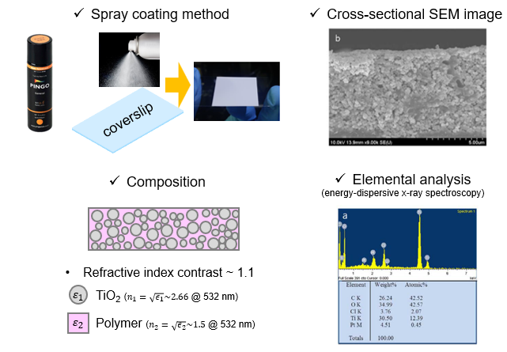
Supporting Figure S1. Detailed information of the disordered substrates used in this study.
Supporting Note S1. Sample preparation of disordered substrates and characterization of near-field speckle patterns. Disordered substrate preparation. We spray commercial Pingo paints (Pingo general, Noroo paint, Korea) on a target sample pre-mounted on a coverslip to deposit a disordered layer of TiO₂ dielectric nanoparticles as described in Ref. 1, 2. The TiO₂ disordered layer must have a thickness of at least a few multiples of the mean free path in the paint to ensure that sufficient scattering occurs. We used a commercial NSOM system (Alpha300S, Witec, Germany) in collection mode to directly observe a two-dimensional intensity profile of the near-field speckle patterns. A 532-nm laser illuminated the backside of the TiO₂ layer and experienced random scattering and formed near-field speckle patterns at the exit surface of the layer. A cantilever-type NSOM probe tip with a nominal aperture of less than 100 nm diameter scans the surface of the layer in a contact mode to register the intensity of the near-field speckle patterns detected by a photomultiplier tube. To determine the minimum grain size of the near-field speckle patterns, we performed a spatial autocorrelation of the measured intensity profile. We estimated the FWHM of its peak. We did not perform any deconvolution on the autocorrelation data with the PSF of the NSOM tip; thus, the FWHM of the autocorrelation peak is a valid upper bound for the speckle grain size.
S2. Implementing dynamic near-field speckle illumination for NS-SOFI imaging
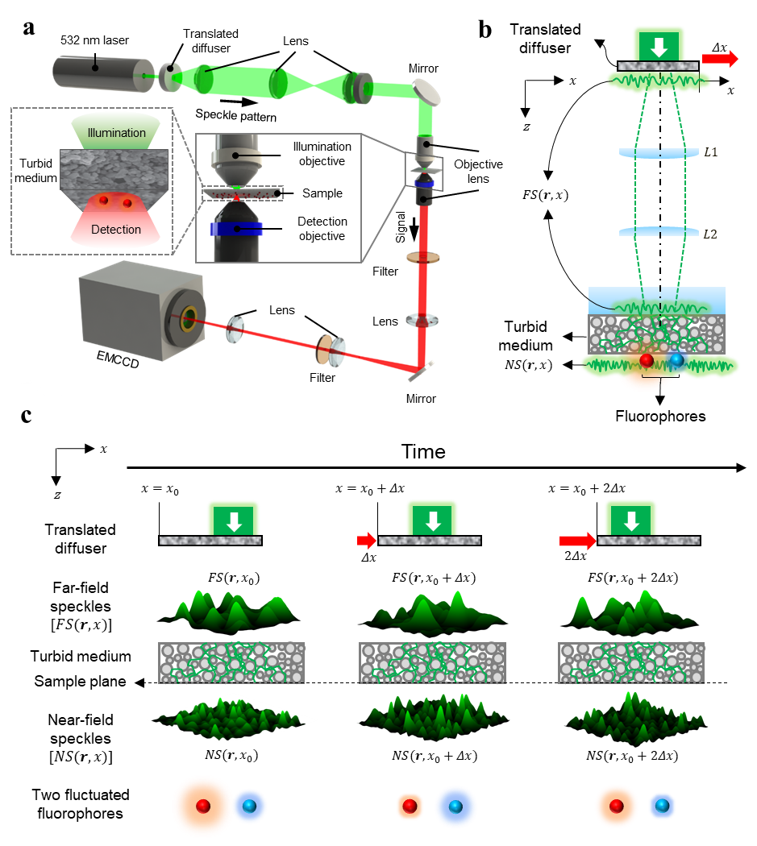
Supporting Figure S2.1. Dynamic near-field speckle illumination for NS-SOFI imaging experiment. a Experimental setup with sample-mounting configuration for NS-SOFI imaging experiment. b Schematic representation of illumination optics in a to produce dynamic near-field speckle illumination. A pair of (pseudo-colored) red and blue sphere describes two independent fluorophores separated within subdiffraction distance under dynamic near-field speckle illumination. c Pictorial description of two-step scattering of a laser beam through the translated diffuser and disordered medium, which results in dynamic near-field speckle illumination at the sample plane.

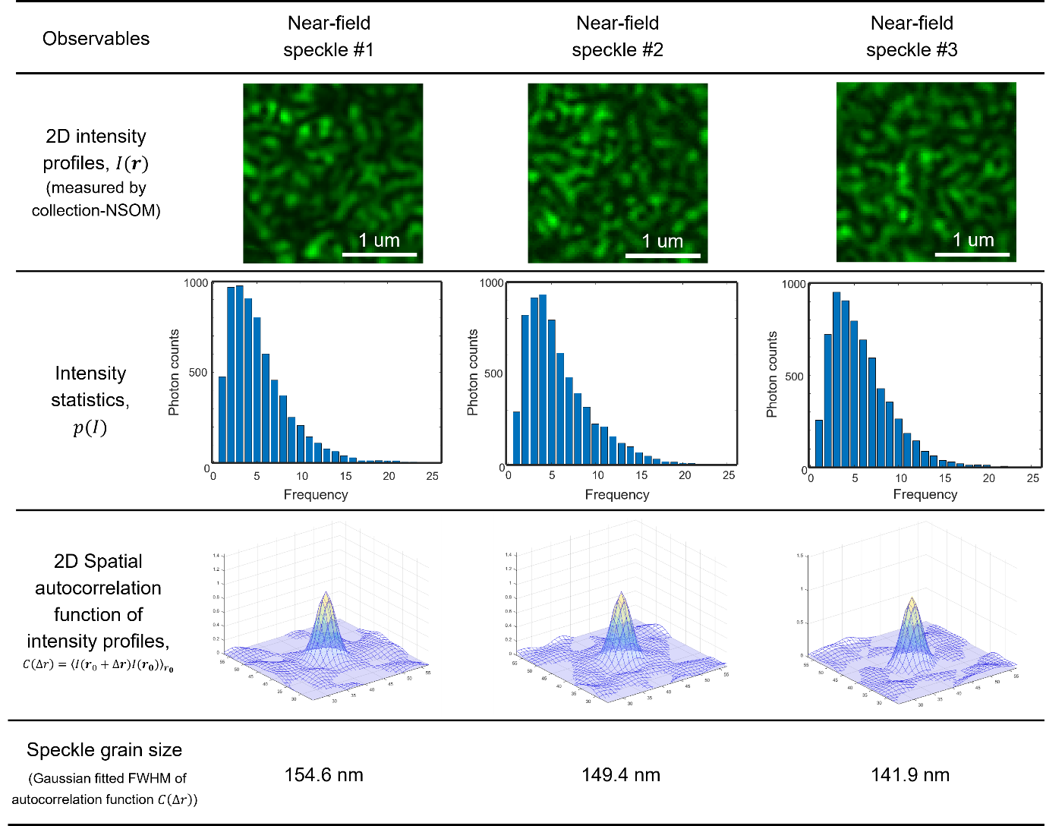
Supporting Figures S2.2. Non-Rayleigh statistics of employed dynamic near-field speckle patterns with their corresponding speckle grain size.
Supporting Notes S2.1. Method to generate dynamic near-field speckle illumination at the sample plane. As a simple means to generate the dynamic near-field speckle patterns exploited in our experiment, a disordered layer of white spray paint comprising TiO₂ nanoparticles and fixative polymer^{1,2} plays a dual role of a sample mount and wavefront shaper for near-field speckles as in Fig. S2a, which is depicted with overall layout of fluorescent microscopy setup in trans-illumination geometry. Figure S2b, c provides illustration of two-step scattering process for intuitive description of how a collimated laser beam turns into dynamic near-field speckle patterns through illumination optics system in Fig. S2a. First, dynamic far-field speckle patterns [$FS\left(r,x\right)$, $r$ denotes the two-dimensional coordinates located at the sample plane and $x$ assigns a position coordinate of the diffuser] are produced when a collimated laser beam is scattered by a translating diffuser³. Next, these dynamic far-field speckle patterns enter the disordered medium after propagation through far-field lens system (depicted as $L1$,$L2$) and are scattered again within the disordered medium, thus turning into near-field speckle illumination [$NS\left(r,x\right)$] at the sample plane. Dynamic variation of the near-field speckle patterns is due to independent far-field speckle patterns varying in sync with the movement of the diffuser ($x_{0}→x_{0}+Δx→x_{0}+2Δx$as in Fig. S2c).

Supporting Notes S2.2. Microscope set-up and imaging procedure. As depicted in Fig. S2a, fluorescence imaging with all the samples was carried out using an inverted optical microscope (IX71, Olympus); its illumination condenser module was replaced by a laser-speckle illumination components in the transmission configuration. A collimated 500-mW 532 -nm laser beam (SDL-532-1000-T, Shanghai Dream Lasers Technology) passed the ground glass diffuser (DG10-1500-MD, Thorlabs) mounted on a motorized linear stage. We deposited a thin layer of TiO₂ nanoparticles on the sample by spraying white paint (Pingo general, Noroo paint) on the sample. Far-field speckle patterns were produced by the multiple scattering events within the diffuser and were imaged on the TiO₂ layer by illumination objective lens (NA0.3, $×$10, UMPlanFl, Olympus). The second multiple scattering within the TiO₂ layer shapes the incident far-field speckles into near-field speckle patterns that excite the target sample in trans-illumination configuration. An image frame was acquired by electron-multiplying charge-coupled devices (EMCCD, iXon 897, Andor) at every translational motion of the diffuser. As the illuminated area on the diffuser changed during the step-scan, dynamic far-field speckle patterns were produced. Near-field speckle patterns produced beneath the TiO₂ layer became dynamic random illumination in the sample; thus, each fluorescent label was exposed to a local fluctuation of excitation intensity. This speckle-induced blinking fluorescence signal is collected by a dry objective lens (NA0.9, $×$80, MPLN, Olympus for Fig. 4, NA0.6, $×$40, LUCPlanFL, Olympus for Fig. 5) and filtered by a dichroic mirror (FF552-Di02, Semrock) and a bandpass filter (FF01-612-69, Semrock for Fig. 4, FF01-560-25, Semrock for Fig. 5). The back-projected pixel size was 40 nm. The EMCCD recorded at least 5,000 frames of the blinking images with an exposure time ranging from 50-100 ms per frame and a gain of 300. This image stack was subjected to a MATLAB algorithm customized for balanced SOFI³ (with a Fourier reweighting routine^{4,5}) up to the third order to reconstruct the final NS-SOFI images. To compensate for drift in large stacks of raw fluorescent images, the axial drift was canceled by a commercial autofocusing system (C-Focus, Mad City Lab), and a sub-pixel registration algorithm⁶ corrected the lateral drift.
S3. Detailed simulation workflows to produce results in Fig. 3.
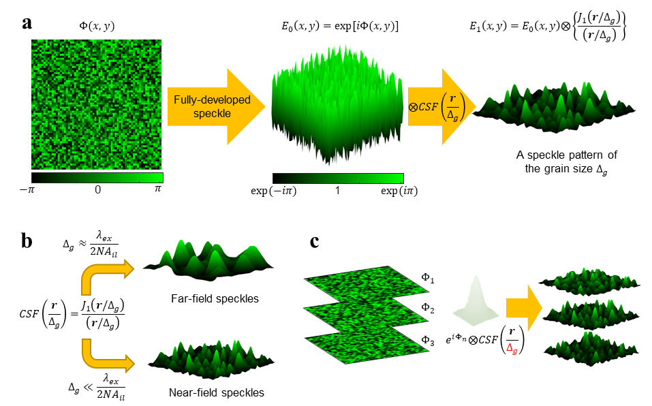
Supporting Figure S3.1 Method to simulate dynamic far- and near-field speckle patterns. a Simulation procedure to generate a single speckle pattern with a target grain size (denoted as Δ_{g}). A speckle pattern with finite grain size is rendered by convolving a random phase grid exp[iФ(x,y)] with a coherent point spread function, CSF(r/Δ_{g})=J₁(r/Δ_{g})/(r/Δ_{g}), where r assigns the two-dimensional position coordinates in the imaging plane and J₁(r/Δ_{g}) denotes the Bessel function of the first order with approximate FWHM equal to the value of Δ_{g}. b In computational setting, freedom to adjust the value of Δ_{g} of the coherent point spread function enables generation of speckle patterns with predefined grain size. The resulting speckle pattern is in far-field (near-field) if the grain size is chosen to be almost identical to (much smaller than) the diffraction limit of the illumination optics, λ_{ex}/(2NA_{il}). c Dynamic speckle patterns having the target grain size Δ_{g} are generated by different ensembles of the random phase grid {exp[iФ_{n}(x,y)]}(n denotes the distinct frame) convolved with the identical CSF(r/Δ_{g}).
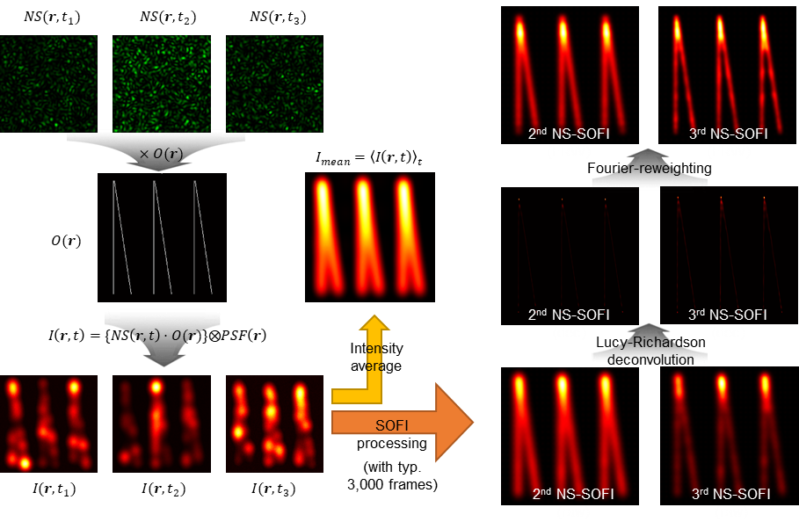
Supporting Figure S3.2 Workflow of NS-SOFI simulation. A Dynamic speckle patterns [denoted as NS(r,t)] modulate the brightness of an fluorophore distribution O(r) upon per-pixel intensity-base multiplication. To simulate incoherent image formation of fluorescence microscopy, each speckle-fluctuated object is convolved with the two-dimensional Gaussian PSF whose FWHM is set to be the predefined value of the diffraction limit of fluorescence detection imaging system. Typically, up to 3,000 frames are exploited to generate both diffraction-limited mean image and super-resolution NS-SOFI images via second- or third-order SOFI processing.

Supporting Note S3. Numerical simulation in Fig. 3 was used to estimate the achievable resolution gain of our NS-SOFI technique in a controlled and quantitative manner, as detailed in Fig. S3.1 and S3.2 A binary image of two diverging filaments was drawn as a ground truth on a 256×256 grid for the resolution test. The size of a single pixel in this computational grid was assigned 10 nm to ensure sufficient oversampling of the predefined diffraction limit, 280 nm, and a measured near-field speckle grain size, 150 nm (Fig. 2d).
As illustrated in Fig. S3.1, a set of speckle patterns having desired grain size was generated by convolving a random phase grid (each pixel value extending from 0 to 2π to simulate a speckle electric field of infinitesimally small grain size) with a two-dimensional Gaussian PSFs whose FWHM coincides with the desired speckle grain size (Fig. S3.1a). Here, FWHM of illumination point-spread function (PSF) can be less than the half of the illumination wavelength to simulate subwavelength speckle patterns in the near-field (Fig. S3.1b). $mbda the eckle electric fieldwavefront of infinitesimally small grain sizen recent quantum technology.NS-SOFI technique. ium$Spatial autocorrelation of each computational speckle pattern is computed to check whether its grain size matches our desired value. Dynamic speckle illumination is simulated as a set of uncorrelated speckle patterns with the same grain size (Fig. S3.1c).
Figure S3.2 describes the computational procedure to describe NS-SOFI imaging experiment with the set of computational speckle patterns generated by the procedures in Fig. S3.1. First, computational speckle patterns are multiplied by the ground truth image on intensity-base to form a set of fluorescent objects whose brightness was modulated by dynamic speckle illumination. Next, each speckle-illuminated object is convolved again with a detection PSF, which is also a two-dimensional Gaussian function, to simulate incoherent image formation process of fluorescence microscopy. The FWHM of this detection PSF is assigned 280 nm, corresponding to the diffraction-limited resolution of the assumed fluorescence detection system. We added 100 background photons to each frame to simulate noise and contaminated the frame by adding Poisson noise. The peak signal-to-noise ratio of the whole image stack was set to be around 10 dB by setting the peak intensity in the entire image stack to 1,000 photons.
The mean image is obtained by the intensity summation of all frames in the speckle-illuminated image stack, which is then divided by the total number of frames. This mean image is equivalent to a single diffraction-limited fluorescence image under wide-field uniform illumination, because the intensity summation of many independent speckle patterns effectively homogenizes their non-uniform illumination intensity distribution. To generate NS-SOFI images, we applied the customized balanced SOFI algorithm^{4,5} to the speckle-illuminated fluorescence image stack. Note that every SOFI processing at any order in this work includes Fourier reweighting procedure^{4,5} after cumulant operation of SOFI algorithm, which was not explicitly denoted in the labeling of super-resolution images in Fig. 3 and 4 for simplicity.
Lateral spatial resolution is defined as the minimum separation at which the dip visibility of a doubly-peaked cross-sectional intensity profile reaches 0.1, corresponding to about 20% dip with respect to the peak intensity (for the exact definition, see Section S4 in Supporting Information and Ref. 7). Dip visibility inspected on the linecut over the mean image (the purple dashed line in Fig. 3b) reaches 0.1 at the separation of 280 nm, which agrees well with our pre-defined FWHM of detection PSF. This confirms that our resolution criterion based on dip visibility is consistent with the diffraction limit set by the FWHM of detection PSF in the simulation.

S4. Dip-visibility resolution criterion for evaluating and comparing lateral resolution of fluorescence images
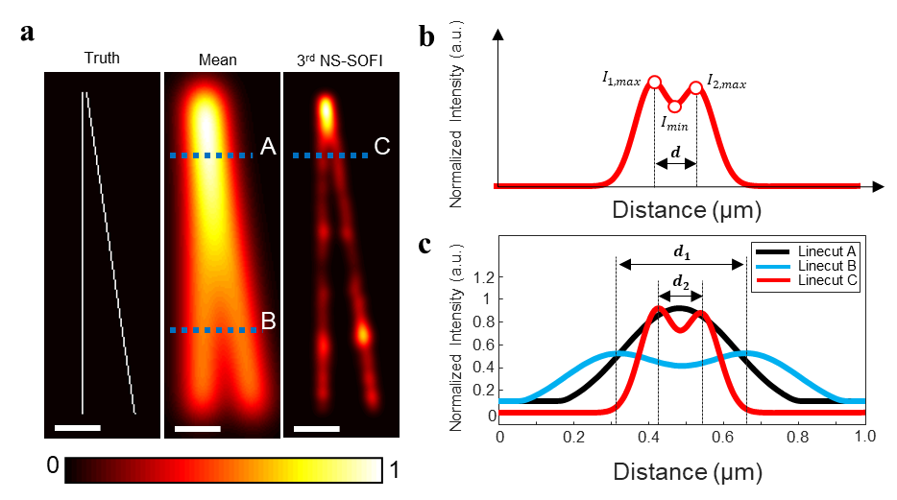
Supporting Figure S4 Definition of lateral spatial resolution and resolution gain used throughout this paper, particularly in Figs. 3. a An example set of ground truth template, mean (diffraction-limited resolution), and 3rd NS-SOFI image (super-resolution third order NS-SOFI) generated as shown in Fig. 3. All scale bars represent 500 nm. b An example of a two-peak cross-sectional intensity profile taken over the 3rd NS-SOFI image. By taking intensity values (I_{1,max} and I_{2,max}) at each peak and the dip (I_{min}), we compute the average visibility $v$ of the two emitters considering their asymmetric intensity (definition below). The spacing d between two emitters at which dip visibility $v$ becomes 0.1 is defined as the lateral spatial resolution of the image. c All three projected intensity profiles taken from mean and 3rd NS-SOFI images (a) have the same dip visibility of 0.1, so d₁ is the diffraction-limited resolution, and d₂ represents the resolution of the super-resolution 3rd NS-SOFI image. The resolution gain of the 3rd NS-SOFI image is defined as the ratio expressing (d₂/d₁)-fold enhancement.

Supporting Note S4. Mathematical definition of dip-visibility resolution criterion.
For fair comparison of the lateral resolution in Fig. 3 and Fig. 4 based on the profiling cross-sectional intensity, we used the concept of dip visibility $v$ defined as
$$v=\frac{\min\left(I_{1,max},I_{2,max}\right)}{\max\left(I_{1,max},I_{2,max}\right)}×\frac{1}{2}\left\{\frac{I_{1,max}-I_{min}}{I_{1,max}+I_{min}}+\frac{I_{2,max}-I_{min}}{I_{2,max}+I_{min}}\right\}$$
Here, dip visibility measures the averaged intensity difference of the minimum point (dip) relative to each peak intensity of doubly-peaked intensity profiles exemplified in Fig. S4b. The first coefficient, which accounts for the asymmetry of two peaks, acts as penalty to the value of $v$.

Supporting Note S5. Caution regarding intensity-based dip-visibility resolution measurement in Fig. 4.
For each of the image in Fig. S4-d, the lateral resolution is determined as the separation between line pairs having dip visibility of 0.1 as inspected in the corresponding cross-sectional intensity profiles in Fig. 4e. However, determining image resolution solely via dip-visibility of line profiles need caution. The intensity-based resolution metric depends on the systematic noise, optical pixel size of the detection imaging system, and potential artifacts in the SOFI image processing. To minimize such error and to produce representative cross-sectional intensity profiles (Fig. 4e), more than 20 intensity profiles are taken in parallel to the dashed lines (denoted by ‘-’ in Fig. 4b-d) and then averaged. Next, we complement our intensity-based resolution measurement with the SEM image (Fig. 4a) for accurate distance calibration.

S6. Preparation of the fluorescent samples in Fig. 4 and Fig. 5
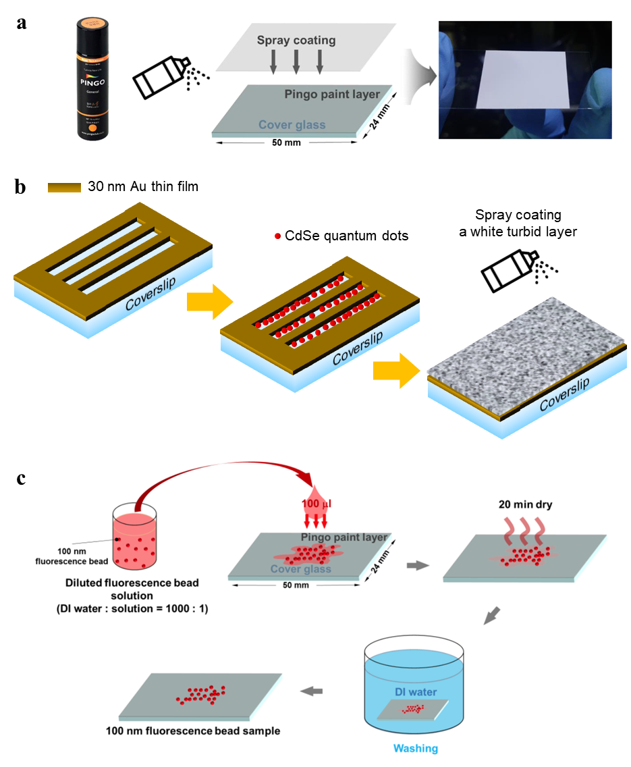
Supporting Figure S6 Schematics of sample preparation process. a Preparation of disordered media to generate near-field speckle patterns at the sample plane. Several trials of spray coating on a bare coverslip with a white paint layer composed of TiO₂ nanoparticles and fixative polymer easily create a few micrometer-thick disordered medium to ensure multiple scattering of incident laser beam. b Three steps to fabricate the fluorescent rulers in Fig. 4. c Dry casting diluted fluorescent beads for the specimen in Fig. 5.
Supporting Note S6.1 Preparation of the fluorescent ruler sample in Fig. 4 and dry-casted fluorescent bead sample in Fig. 5.
The fluorescent ruler sample shown in Fig. 4 was fabricated by the three steps shown in Fig. 5. First, a 30-nm gold film was deposited on bare coverslips by electron-beam evaporation; then, a focused ion beam milled predefined line patterns on the film. These ruled gold-free regions were then silanized (as detailed in the Supporting Note S6.2) so that CdSe colloidal quantum dots were deposited next. Lastly, a disordered medium of TiO₂ nanoparticles, with a thickness of more than a few micrometers, was deposited by spray-coating. This fluorescent ruler pattern offers a convenient way to measure lateral spatial resolution in an experimental setting. Line arrays of gradually decreased spacing are numbered to quickly identify the line pairs resolved before and after super-resolution processing. Fluorescent beads sample in Fig. 5 deposited on the disordered medium is prepared by dry-casting method as described in Fig. S6c.

Supporting Note S6.2. Preparation of the coverslip surface before functionalizing colloidal quantum dots
- Cover slips were cleaned with piranha solution then washed three times with ultrapure water under sonication.
- Glasses were then immersed for 5 min in a 5% (v/v) solution of (3-aminopropyl)trimethoxysilane in ethanol and kept in a thermostat at 60 °C.
- The amino-modified glasses were washed three times under sonication with ethanol and then dried under a nitrogen stream.
- PSS (poly-sodium4-styrene sulfonate) and PAH (polyallylamine hydrochloride) at concentrations of 3 and 2 mg/mL, respectively, were dissolved in pure water.
- For layer-by-layer assembly of PSS/PAH on functionalized glass, the substrates prepared through steps 1 to 3 were immersed in a PSS solution for 20 min, followed by a wash in water for 5 min. Then these substrates were immersed in a PAH solution for 20 min, followed by a wash in water for 5 min. Finally, colloidal quantum dots (Nanosquare, 620 NSQDS-AC) are attached to the functionalized glass surface.

References for Supporting Information
1. Park, J. H. et al. Subwavelength light focusing using random nanoparticles. Nat. Photonics 7, 454–458 (2013).
2. Park, C. H. et al. "Full-field subwavelength imaging using a scattering superlens." Physical review letters 113, 113901 (2014)
3. Kim, M., Park, C., Rodriguez, C., Park, Y. & Cho, Y.-H. Superresolution imaging with optical fluctuation using speckle patterns illumination. Sci. Rep. 5, 16525 (2015).
4. Geissbuehler, S. et al. Mapping molecular statistics with balanced super-resolution optical fluctuation imaging (bSOFI). Opt. Nanoscopy 1, 1–7 (2012).
5. Dertinger, T., Colyer, R., Vogel, R., Enderlein, J. & Weiss, S. Achieving increased resolution and more pixels with Superresolution Optical Fluctuation Imaging (SOFI). Opt. Express 18, 18875 (2010).
6. Guizar-Sicairos, M., Thurman, S. T. & Fienup, J. R. Efficient subpixel image registration algorithms. Opt. Lett. 33, 156-158 (2008).
7. Geissbuehler, S., Dellagiacoma, C. & Lasser, T. Comparison between SOFI and STORM. Biomed. Opt. Express 2, 408 (2011).

